**SWINBURNE UNIVERSITY OF TECHNOLOGY**

**COS30045**

**Project Reflection**

|  |  |  |
| --- | --- | --- |
| **NAME & STUDENTID** | **:** | **Nguyen Gia Binh (104219428)** |
|  |  |  |
| **CLASS** | **:** | **COS30045** |
| **LECTURER**    **TUTOR** | **:**    **:** | **HOANG XUAN TUNG**  **(**txhoang@swin.edu.au**)**  **HOANG XUAN TUNG**  **(**txhoang@swin.edu.au**)** |

**Hanoi, April 6, 2024**

**TABLE OF CONTENTS**

TABLE OF CONTENTS

**CHAPTER 1: INTRODUCTION**

**CHAPTER 2: REFLECTION**

2.1: Concept

2.2: Data processing

**CHAPTER 3: CONTRIBUTION**

3.1: Data finding

3.2: Data processing

3.3: Writing/Researching code

**CHAPTER 4: COLLABORATION**

4.1: Discord server

4.2: Github Repository

**CHAPTER 5: CONCLUSION**

**REFFERENCE**

**CHAPTER 1: INTRODUCTION**

Migration is a natural and inevitable aspect of human history. In the current globalized world, international migration has become more common. Understanding these complex forced migration dynamics is crucial for policies and international relations efforts to resolve the core Invasion and address the refugee crisis humanely based on international law. The report will establish an individual perspective on the data visualization project focusing on migration from Ukraine since Russia invasion 24 February 2024. The goal of this project was to create an interactive application that allows users to examine and interpret migration statistics in an accessible and enlightening way. Through the application of data visualization principles and coding skills, the intention was to establish an appealing digital interface that clearly conveys the complex aspects of migratory movements.

Throughout this essay, I’m taking a deep dive into my own academic growth and the contributions I made to our group project. It’s been a journey of significant learning milestones. I’m going to break down how I managed to apply these to our interactive visual tool. This isn’t just about the end result, though—it's also about the process, including the programming techniques I got to grips with. On top of that, I'm reflecting on how we all worked together on this project. I'll get into my role and how I fit into the group, plus how that changed as the semester went on. There were definitely a few roadblocks along the way, and I'll be talking about those too—what went down, how we dealt with it, and how we pulled it all together for a win in the end.

**CHAPTER 2: REFLECTION**

**2.1: Concept**

Throughout this project, I have got a grip on 2 fundamental aspect of data visualization: data preparation to lay the foundation for creating informative and impactful data visualizations and interactivity to help user more engage in the visualization.

Data preparation is like cleaning and organizing your workspace before a project. Raw data is often messy, containing errors, inconsistencies, and inconsistencies. We prepare the data and tackles these issues by collecting the right information, formatting it for analysis, and ensuring its accuracy. This meticulous cleaning process is essential as ensures our visualizations and analysis are built on a solid foundation, leading to trustworthy insights and reliable conclusions.

Interactivity transforms data exploration from a passive experience into an active discovery process. Users can engage with the data on their terms, uncovering hidden patterns, drilling down for deeper understanding, and personalizing their journey through the information. This interactivity fosters curiosity and empowers users to become active participants in the data story, leading to richer insights and a stronger connection with the information.

Together, data preparation provides a solid foundation, and interactivity empowers users to truly engage with the data story. Considering this advantages, I try to embrace them as much as possible during the design process .

**2.2: D3js**

Throughout the duration of our project, I engaged with several coding strategies, prominently the implementation of D3.js—a robust JavaScript framework—to generate interactive visualizations. This tool, also referred to as Data-Driven Documents, granted us the capability to flexibly work with data to produce visuals that respond and adapt to that data.

Focusing on migration flow from Ukraine to European country after the invasion of Russia, we harnessed the power of D3.js to craft graphics that were not only visually striking but also full of insight. Techniques such as data manipulation, data binding, and dynamic rendering were key to converting the crude migration figures into significant graphical depictions.

The manipulation of data was a pivotal aspect of our approach. We meticulously refined the migration statistics to tailor them for visualization purposes, including grouping the data by various factors like time, country of origin, and destination.

We integrated the data with visual components such as bars, lines, and map using data binding methods. This integration formed a link between the data and its graphical display, facilitating real-time updates to the visualization in accordance with data modifications or user input.

Furthermore, our rendering methods were driven by the data, enabling us to spontaneously create and adjust visual elements grounded in the migration statistics. Utilizing scales, we translated quantitative data into corresponding visual attributes, crafting precise histograms, trend lines, and maps that accurately depict migratory trends.

In summary, by utilizing D3.js and its related programming techniques, we were able to produce interactive and enlightening visualizations that successfully delineate migration patterns from Ukraine. Our strategic application of data manipulation, data binding, and dynamic rendering has translated complex datasets into clear and engaging graphical viualization.

**CHAPTER 3: CONTRIBUTION**

To start, I contribute not just at least 92% of the viewable project but also the idea, the planning and almost everything else in this project. Before diving deeper into what I did in details, let me clarify one thing first, the other teammate did contribute something but it is so low effort and quality that I just can not accept it, it took him 3 weeks to deliver something so subpar to what I focus on doing in 2 days. That is not to say what I did was very good,complex and high level. In fact, mine was very basic and simple compare to other teams, it just that his work quality is just that low.

**3.1: Data finding**

I collected data from a range of authoritative entities to examine Russia's invasion into Ukraine. The data is sourced from IOM (International Organization for Migration), CEDOS (Center for Economic Strategy), CEEOL (Central and Eastern European Online Library), Humanitarian Data Exchange (HDX), and EuroStat. Each repository of information is carefully integrated and analyzed to generate meaningful visualizations. IOM is recognized for its migration expertise, CEDOS provides valuable insights on Eastern European socio-economic trends, CEEOL is a portal for pertinent scholarly work, HDX offers comprehensive data relevant to humanitarian crises, including demographics, geographical boundaries, and information on displaced populations, while EuroStat is the provider of official statistical data. The collective utilization of these diverse sources affords a rich and up-to-date dataset for a thorough analysis of the subject matter.

**3.2: Data processing**

These datasets required meticulous data cleaning and reformatting to align with the structural standards essential for D3 visualization.

The line chart creation posed some challenges as no single source provided a complete dataset, this required data imputation to fill in gaps. Attention was concentrated on specific data columns that detailed the year, originating country, and refugee counts. Simultaneously, unuse columns were trimmed to streamline the data architecture, thereby optimizing performance. For the missing monthly data, a supplementary dataset from the Humanitarian Data Exchange provided the exact dates needed for cross-verification.

For the stacked bar chart, which illustrated internally displaced persons in Ukraine, reports from the International Organization for Migration (IOM) provided the data. These reports, conducted at the end of 2022 and in February 2024, included demographic sections that remained consistent across both reports.

The geomap data was more straightforward, The data is taken from <https://data.unhcr.org/en/situations/ukraine> because they have the most up to date and most precise, consistent information regarding our topic.

**3.3: Writing/Researching code**

The geomap coding turned out to be less complex than I initially anticipated. The main difficulty arose from adapting it to the constraints of the front-end layout. Europe presented a unique challenge with two territories far removed from the main continent, which I chose to exclude due to the absence of substantial data.

The line chart presented its own set of challenges, dealing with two distinct data handling scenarios. In total, there are five line charts: one spanning from 2021 to the present and four individual ones for each year. Furthermore, the line chart's tooltip is distinct from that of the geomap, designed to be constantly visible to indicate the nearest data point. I frequently faced issues where 'pageX' was not correctly defined, as well as with 'clientX' and 'Y' coordinates which id solve by simply define another tooltip with different associated name like class and id form that of the one in Geomap visualization. Another issue was the suboptimal code performance. The chart's time format data caused tooltip malfunctions upon execution. On closer inspection, I found that D3 sometimes struggles with this format and would unpredictably fail to process it when you load the page for the first time and it would failed randomly as well when refreshing the page while disable cache is active.

Crafting the stacked bar chart also posed significant issues. Although its construction was straightforward, as outlined in Lab 7.3, I encountered insurmountable challenges in implementing tooltips for the rectangle (rect) elements. Once drawn, the rectangles seemed to lost it abilities of access the data needed to determine their length. Despite numerous attempts and method testing, I also realized that JavaScript would default to calculating the key category regardless of my specified row or column orientation, which did not align with my intended format and could potentially mislead the viewer. This is probably a result of my inexperience in Javascript and not the language itself though.

Finally, the geomap was very easy to make since all the code I needed had already been done since lab 8.2 and I just need to add hover effect to show the tooltip.

Here are some example of all the charts :

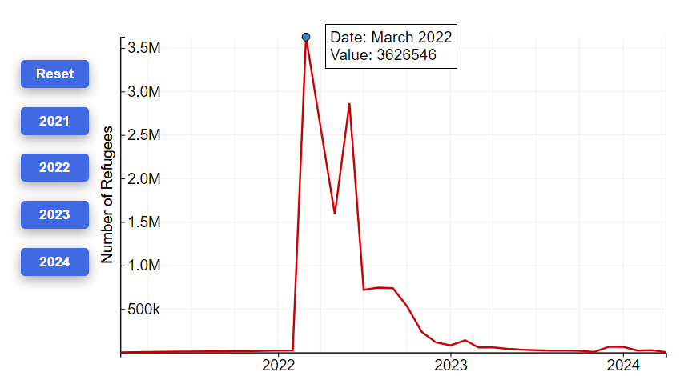

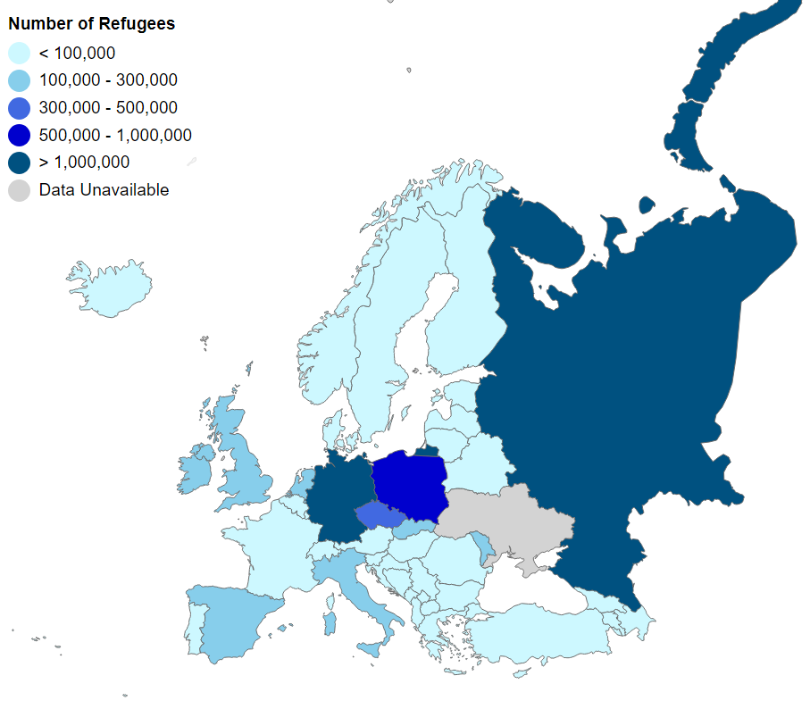

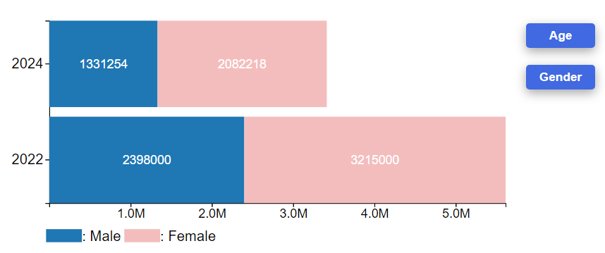

**CHAPTER 4: COLLABORATION**

Ever since the start of the project which is around week 2, I have tried to make extensive communication and contribution to the project regardless of my teammate performance. I initialize the github repository, open discord server and contributing with data source and reccomendation on what I think that can be use for the project.

**4.1: Discord server**

I open a discord server to upload link and file on datasets that I think is possible to use in the project and as you can see, the other teammate contributes 2 times total in the past 3 months, not just that but before we land on the forced minration from Ukraine, I was doing forced migration in Gaza due to Isarael attack too.

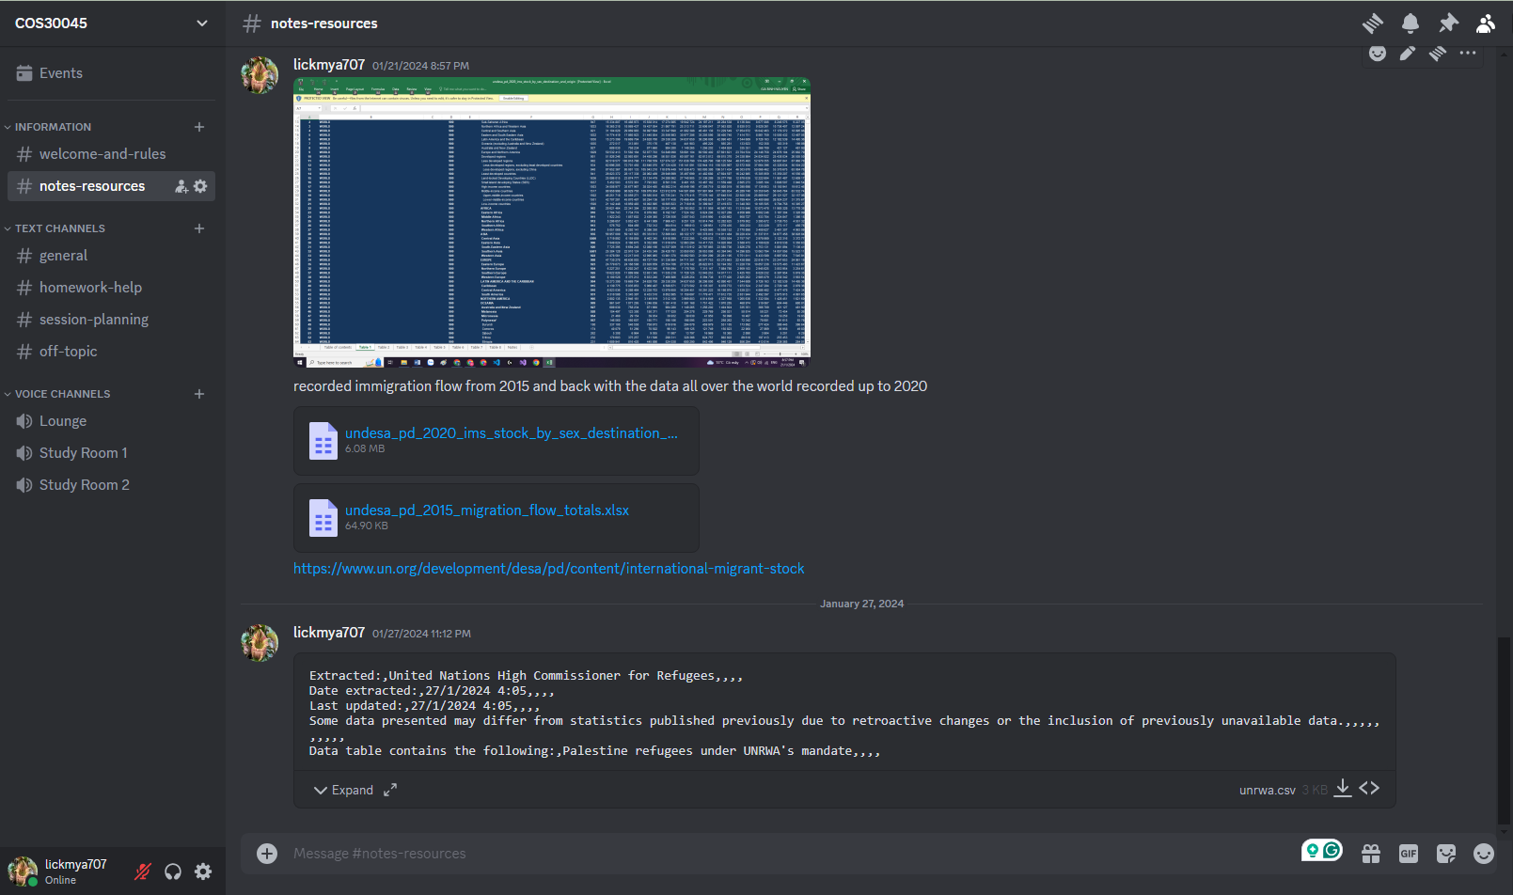

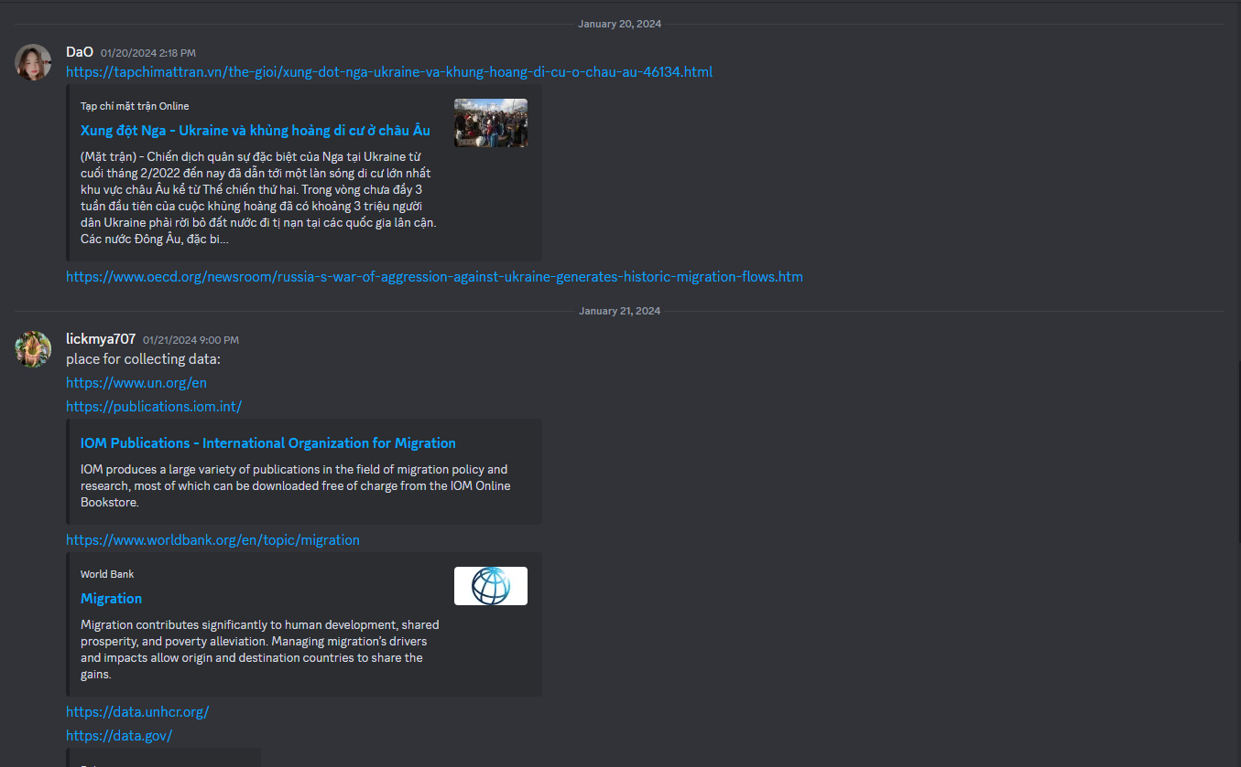

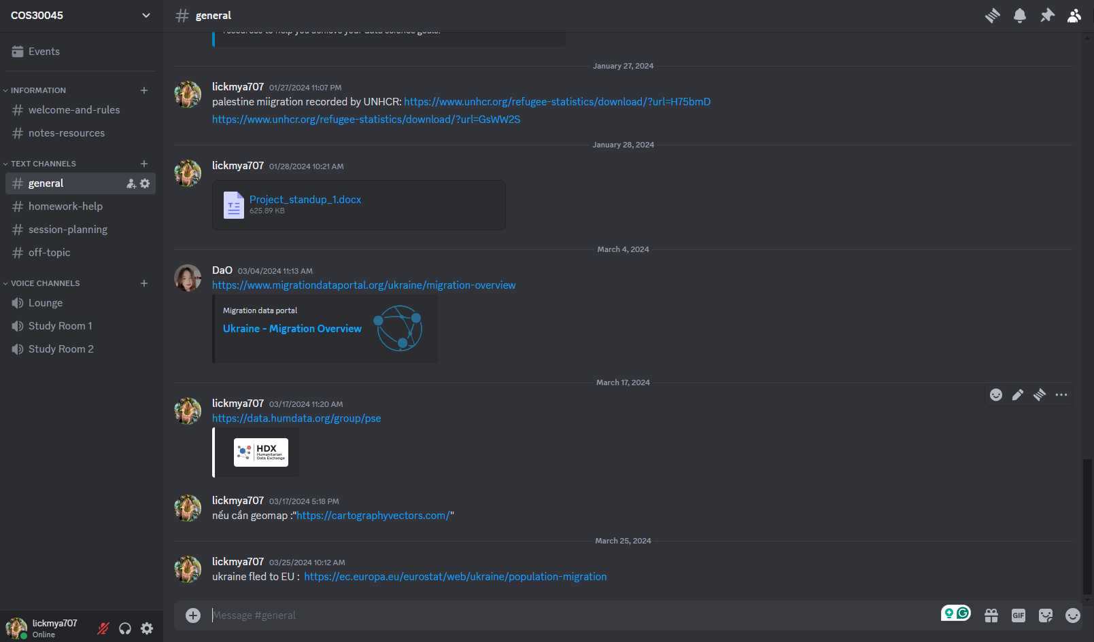

**4.2: Github Repository**

Github Repo was initialize by me since we need a common ground to send and update file makign the process of updating the code and cross fixing easier. Here is my contribution as of 1:03 PM 07/04/2024:

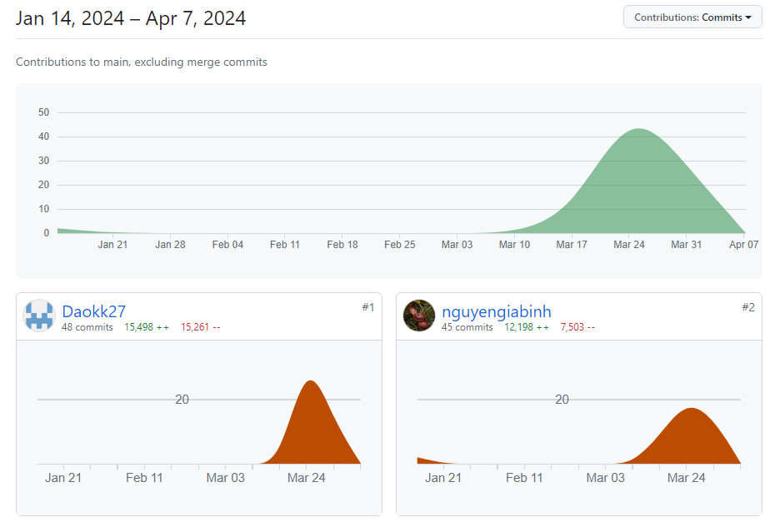

Don’t be trick by Daokk27 contribution of 15,498 addition and 15,261 deletion as on 29 th March 2024 I got fed up and delete all my contribution because of the jar droppping low quality of work that Dao delivered after 3 weeks of non communication unless I ask him on the progress. He merged his branch containing ~~15,000 lines of the geojson file the following day and gain thousands of addition and deletion. Here is the stat that add my contribution up to 92% on 29 th March 2024:

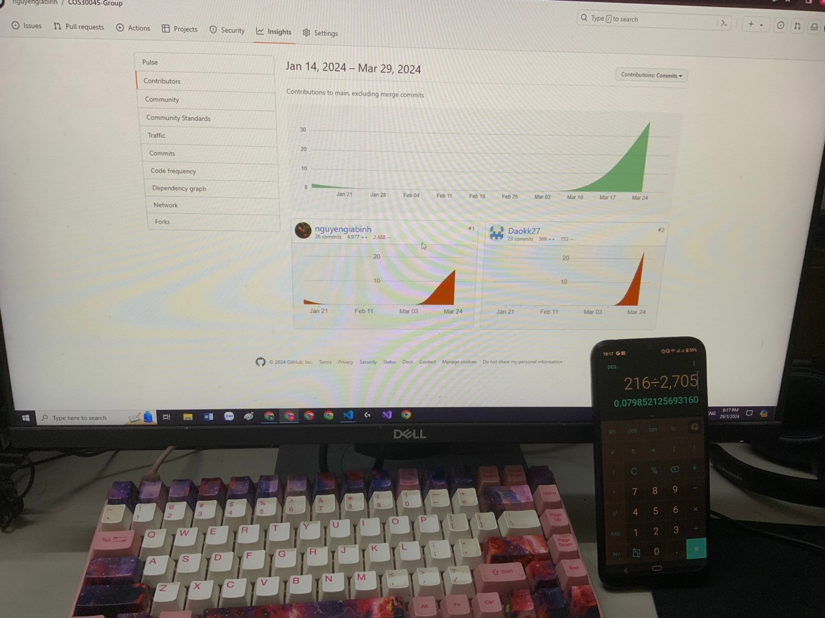

My deleted works are stored on my local computer. As for me, after some calculation, my work is about 95% of total viewable project.

**CHAPTER 5: CONCLUSION**

To conclude, this project on migration data visualization has significantly broadened my learning, granting me insights into the realms of data representation and programming. I've acquired substantial knowledge in the principles of data preparation and interactivity, adeptly managing vast datasets and providing an intuitive user experience. Utilizing D3.js, I've honed my skills in data manipulation, binding, and dynamic rendering, which has enabled me to convert raw figures into engaging visual narratives. In essence, this project has been pivotal in advancing my analytical and technical competencies, underscoring the crucial role of effective data visualization.

Working in a small team presented its challenges. With only two members, the absence of contribution from one can significantly increase the burden on the other.

In conclusion, the skills and knowledge acquired during this project equip me to create more effective visualizations in the future, thus improving the utility and impact of the visual data presented.

**REFFERENCE**

*Europe - mixed migration flows to Europe, yearly overview (2023)*. Europe - Mixed Migration Flows to Europe, Yearly Overview (2023) | Displacement Tracking Matrix. (n.d.). https://dtm.iom.int/datasets/europe-mixed-migration-flows-europe-yearly-overview-2023

Filipchuk, L., Lomonosova, N., Syrbu, O., & Kabanets, Y. (2022, May 4). *Forced migration and the war in Ukraine (February 24 - March 24, 2022)*. Cedos. https://cedos.org.ua/en/researches/forced-migration-and-the-war-in-ukraine-february-24-march-24/

Koroutchev, R. (n.d.). *UKRAINIAN MIGRATION DURING THE FIRST YEAR AFTER THE BEGINNING OF THE RUSSIAN ARMED CONFLICT IN 2022UKRAINIAN MIGRATION DURING THE FIRST YEAR AFTER THE BEGINNING OF THE RUSSIAN ARMED CONFLICT IN 2022*. PDF Viewer. https://www.ceeol.com/search/viewpdf?id=1207439

*Statistics explained*. Statistics Explained. (n.d.). https://ec.europa.eu/eurostat/statistics-explained/index.php?title=Temporary_protection_for_persons_fleeing_Ukraine_-_monthly_statistics

*Ukraine - internal displacement report - General Population Survey Round 11 (25 November - 5 December 2022)*. Ukraine - Internal Displacement Report - General Population Survey Round 11 (25 November - 5 December 2022) | Displacement Tracking Matrix. (n.d.). https://dtm.iom.int/reports/ukraine-internal-displacement-report-general-population-survey-round-11-25-november-5

*Ukraine - area baseline assessment (raion level) - round 33 (February 2024)*. Ukraine - Area Baseline Assessment (Raion Level) - Round 33 (February 2024) | Displacement Tracking Matrix. (n.d.). https://dtm.iom.int/reports/ukraine-area-baseline-assessment-raion-level-round-33-february-2024

*Situation Ukraine refugee situation*. UNHCR Data Portal. (n.d.). https://data.unhcr.org/en/situations/ukraine

*Home*. Humanitarian Data Exchange. (n.d.). https://data.humdata.org/dataset/ukraine-data-explorer-inputs

International Migrant Stock 2020. (n.d.). https://www.un.org/development/desa/pd/sites/www.un.org.development.desa.pd/files/files/documents/2021/Jan/undesa_pd_2020_international_migrant_stock_documentation.pdf

Canton, H. (2021). United Nations Relief and Works Agency for Palestine Refugees in the Near East—UNRWA. In *The Europa Directory of International Organizations 2021* (pp. 286-289). Routledge.